Non-linear Least Squares Fitting
Summary:
The idea is that we have a series of observations at different time points and having estimated the period of the time series (using whichever is the preferred method) we are now trying to find the phase offset of the time series. To do this we fit a single cosine of known period to the data and try to find the constant offset, amplitude and phase which give the best fit to the data. So our model of the data is:
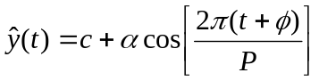
This has three unknown parameters: c, a constant offset term, α is the amplitude of the cosine component and φ is the phase offset of the cosine component; and P is the known period of the cosine component. In order to get good estimates for our unknown parameters we need to have reasonable initial estimates for them. This will be discussed later. The initial values can then be improved through successive iterations of adding a small perturbation and evaluating the effect on the sum of squares residual. As the estimates improve, so the sum of squares residual should decrease. The algorithm is said to be converged when the ssr does not change substantially between two iterations of the algorithm.
Theory:
The objective is to find the values of c, α and φ which best fit the data. We do this by iteratively adding a small perturbation to each of the parameters, finding the error, or residual, between the data and our model of it and minimizing the square of the error with respect to all three parameters.
For any point y(t) we can calculate the residual as the difference between the value estimated by our model above and the true value of y:
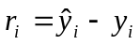
And we want to minimize the sum of the square of the errors, i.e.
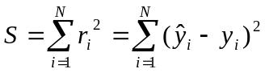

Let p_{i} represent the set of parameters (c, α and φ ) at the ith iteration of trying to improve the estimate. Then we obtain the values of the parameters p_{i+1} at the next iteration by adding a small offset Δ. The quantity we want to minimize is S(p_{i+1}), the sum of the squared residuals. Now
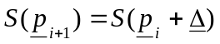
and so the value of S(p_{i+1}) can be approximated using the Taylor series expansion as follows:
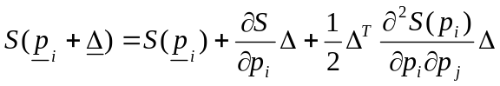

The last two components of the equation above can be substituted. Because 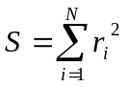then
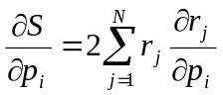
And
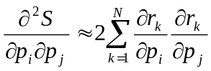
The latter equation assumes that 2nd order derivatives can be ignored (this is one of the assumptions of the Gauss Newton method of non-linear least squares estimation).
Now the partial derivatives, when written in matrix format, are technically known as Jacobians and can be represented as:
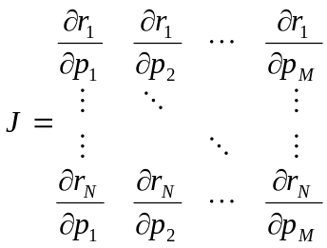
With individual elements defined as 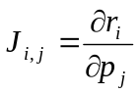
So our approximation of S(p_{i+1}) can be written as:
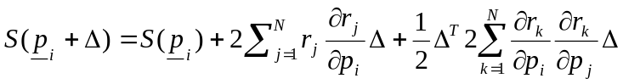
Or in matrix notation:
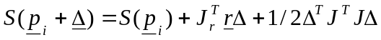
We are trying to find the minimum values for Δ, so, in a similar way to when working with linear least squares, we differentiate the above equation with respect to Δ and set the result to zero:
This gives us the, so-called, normal equations which we attempt to solve for Δ:
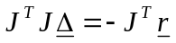
We can use these values of Δ to update our parameter estimates and then calculate the new sum of residuals, S(p_{i+1}), which should be less than the previous sum of residuals. If the sum of residuals has decreased we can repeat the procedure (adding a small perturbation to the parameter estimates) and keep going until there is no improvement (i.e. increase) in the sum of residuals.
How does this work in practice for our particular example?
We need to set out initial estimates for our parameters of interest. The amplitude is estimated as half the distance between the maximum and the minimum data points. The offset is estimated as the maximum data point minus the amplitude, and the phase is estimated as the time at which the highest peak within the first period occurs. These are only approximations to start the algorithm, so no need to worry about noise on the maximums etc.
amp = (max(data) - min(data))/2;
offset = max(data) - amp;
[dummy,phi]=max(data(1:period+1));
phi = phi-1;

So now we have initial estimates for our parameters of interest we can try and improve them using the Gauss Newton method outlined above. The jacobian will contain the partial derivatives of the residual with respect to our three parameters of interest: c, α_{1,} φ₁ and τ₁. The residual is given by:

And our model, for the data is:
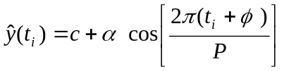
This gives the following partials:
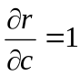 | partial (1)
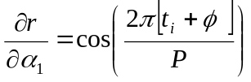 | partial (2)
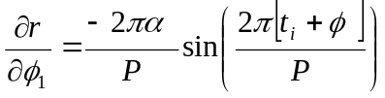 | partial (3)

Armed with this information we enter a parameter estimation loop as follows:
JTJ is the Jacobian squared,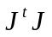in the derivation above, and so will be a matrix of size (3,3). This is initialised to zero and the element (i,j) is defined as:
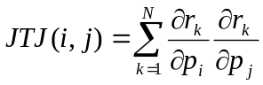
where the summation is over all time points.
JTD is the (partials x residuals) matrix, 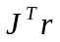 in the derivation above, and so will be of size (3,1). Again this is initialised to zero and the ith element is defined as:
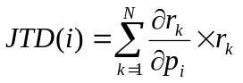
where the summation is over all time points.
For each time point we can calculate the difference between the data and the estimated curve (this is just the same as the residual calculated above) and calculate the partials
First we calculate the estimated curve using our estimated parameters

ret = offset;

arg=(2*pi*(times(i)+phi))/period;
if (abs(arg) < 1e18)
ret = ret+amp*cos(arg);
end;

fxs(i)=ret;

Then we calculate the residual:
dif=(y(i)-fxs(i))

We then calculate the partials, see above, at that time point.

partials(1,1) = 1;
partials(2,1) = cos((2*pi/period)*(times(t) + phi));
partials(3,1) = (-2*pi*amp)/period) *sin((2*pi/period)*(times(t) + phi));

When this has been done for all time points we set up two matrices and initialize them to zero:
We can then load up the two matrices:
For each time point (n):
for i = 1 : no of params
JTD(n) = JTD(n) + r_{i} x partial(n)
for j = 1 : no of params
JTJ(i,j) = JTJ(i,j) + partial(i) x partial(j)
end j
end i
And because the matrix JTJ is symmetric we can populate the bottom half of the matrix as follows:
for i = 1 : no of params
for j = 1 : no of params
JTJ(j,i) = JTJ(i,j)
end j
end i
end time-point loop
We now solve the normal equation, which using the matrices we have set up above, has become:
JTJ e = JTD
This can be done by any standard technique. In the Java code SVD (singular value decomposition) was used, although the same answers were also obtained by using QR decomposition.
We then use the values obtained for e to update our parameter estimates according to the Gauss Newton method:
for i = 1 : no of params
answers(i) = answers(i) + e(i)
end i
Calculate the value of our model,, for the data using the newly calculated parameters, and calculate the new residuals using our updated model:
and use these to calculate a new sum of squared residuals
new ssr = r₁xr₁ + r₂xr₂ + r₃xr₃ + r₄xr₄ + …………
Compare this new ssr with the best ssr so far. If the new ssr is better (i.e. smaller) update the best ssr and best answers to be the new ssr and associated new answers
If new ssr < best ssr
best ssr = new ssr
best answers = answers
end if
Now see if the ssr has converged. To do this we check whether the ssr has changed by less than one part in 1 thousand:
If |(new ssr/old ssr) – 1| > 1x10⁻³
residue has not yet converged and we repeat.
If |(new ssr/old ssr) – 1| < 1x10⁻³
residue has converged and we break out of the convergence loop.

Once everything has converged we need to make sure that we have the best set of parameters and corresponding ssr.
If best ssr < new ssr then update our ssr and associated parameters to be the best ones available;
new ssr = best ssr
answers (i) = best answers (i)
Then use these answers to re-evaluate the final best model,

A Taylor Series expansion represents a function as an infinite sum of terms that are calculated from the values of the function’s derivatives at a single point.

